**Multilevel Feedback Queue (MLFQ) Scheduling Algorithms Performance and Utilization Comparisons, A Simulation Study**

Al Refai Mohammed N.

Yazan Monther alhelo

Software Engineering Department

Zarqa University, Zarqa, Jordan

refai@zu.edu.jo

**Abstract – This research investigates the impact of context switching on the Multi-Level Feedback Queue (MLFQ) scheduling algorithm** (1)**. It aims to analyze performance metrics such as throughput, response time, and CPU utilization while manipulating the frequency of context switches. The study explores techniques to minimize negative effects, such as reducing unnecessary context switches** (2) **and improving adaptiveness** (3)**. The findings will inform operating system designers and developers, enhancing resource allocation efficiency in multitasking environments. Ultimately, this research seeks to improve overall system performance and user experience. Index Terms – Operating System, Scheduling Algorithms, Multilevel Feedback Queue, Optimization, Process Scheduling.**

**Index Terms – Operating System, Scheduling Algorithms, Multilevel Feedback Queue, Optimization, Process Scheduling.**

1. INTRODUCTION

Context switching is a critical aspect of modern operating systems, enabling efficient multitasking and resource allocation (4). It involves the process of saving the current state of a running process, allowing the operating system to switch to another process and resume execution (2). However, the frequent occurrence of context switches can impose significant overhead on system performance, particularly in the context of scheduling algorithms.

One widely used scheduling algorithm is the Multi-Level Feedback Queue (MLFQ) algorithm (3). The MLFQ algorithm employs multiple queues with different priorities, allowing processes to move between queues based on their behavior and resource requirements (5). This dynamic approach aims to provide fairness and responsiveness to processes with different characteristics. However, the frequency of context switches within the MLFQ algorithm may impact its overall effectiveness and efficiency.

This research aims to investigate the impact of context switching on the performance of the MLFQ scheduling algorithm. By analyzing various performance metrics, such as throughput, response time, and CPU utilization, we seek to understand how context switches affect the algorithm’s execution. The research will consider both synthetic workloads and real-world applications to ensure the findings are applicable in different scenarios.

To address this research objective, we will design and conduct experiments that manipulate the frequency of context switches while measuring the associated performance metrics [3]. The experiments will be conducted on a testbed comprising a representative operating system environment and a diverse set of workloads [4]. The performance data collected will be analyzed and compared to identify patterns and trends related to the impact of context switching on the MLFQ algorithm.

Furthermore, this research will explore potential techniques to mitigate the negative effects of context switching on the MLFQ algorithm’s performance. This may involve investigating strategies to reduce unnecessary context switches [3], optimizing the algorithm’s adaptiveness to dynamic workload changes (6), or considering alternative approaches to context management (7).

The outcomes of this research will contribute to a deeper understanding of the relationship between context switching and the MLFQ scheduling algorithm. By identifying the impact of context switching on system performance, operating system designers and developers can make informed decisions when implementing and configuring scheduling algorithms. This knowledge can lead to improvements in resource allocation efficiency, ultimately enhancing overall system performance and providing a better user experience.

1. SIMULATION METRICES

In order to investigate the relationship between context switching and various performance metrics, including quantum, average response time, average waiting time, and average turnaround time, a simulation of the Multilevel Feedback Queue (MLFQ) scheduling algorithm was implemented (8). The MLFQ algorithm was configured to use a Round Robin (RR) scheduling policy for each level, with a First-In-First-Out (FIFO) policy for priority promotion between levels (4).

During the simulation, several key metrics were measured and analyzed to assess the impact of context switching on the performance of the MLFQ algorithm:

a. Quantum: The quantum represents the time quantum or time slice assigned to each process at each level of the MLFQ (9). By varying the quantum value, different context switching frequencies can be achieved, allowing for the exploration of their effects on the system’s performance.

b. Average Response Time: The average response time measures the time from when a process arrives in the system until it starts executing (6). It provides insights into how quickly processes receive CPU time and is an important indicator of system responsiveness.

c. Average Waiting Time: The average waiting time measures the time a process spends in the ready queue, waiting to be assigned CPU time (5). It reflects the overall efficiency of the scheduling algorithm in managing process queues.

d. Average Turnaround Time: The average turnaround time measures the total time taken for a process to complete execution, including both CPU execution time and waiting time (10). It provides an overall view of process execution efficiency.

By manipulating the context switching frequency through the quantum value, the simulation enabled the examination of how different frequencies impact the aforementioned metrics. The simulation code was designed to collect and record these metrics for further analysis and comparison [1].

It is important to note that the simulated MLFQ (RR, RR, FIFO) configuration allowed for a controlled exploration of the relationship between context switching and performance metrics. The simulation results will provide valuable insights into how context switching frequency affects the efficiency and responsiveness of the MLFQ algorithm, thereby informing potential optimizations or adjustments to enhance system performance.

1. SIMULATION SETUP

To investigate the impact of the quantum value on the number of context switches in the Multilevel Feedback Queue (MLFQ) scheduling algorithm, a simulation was conducted with varying process counts of 100, 1000, and 10000 . The simulation involved manipulating the quantum value to observe its effect on the context switching behavior . By simulating different process counts, the study aimed to explore how the quantum value influences the number of context switches in scenarios with varying workloads. The process counts were selected to represent different system loads, enabling a comprehensive analysis of the impact of the quantum value across a range of workload intensities (6).

The simulation was performed by executing the MLFQ algorithm and measuring the number of context switches for each quantum value and process count combination. By systematically adjusting the quantum value, the study aimed to identify any patterns or trends in the relationship between the quantum and the number of context switches (9).

The simulation setup also accounted for other relevant factors, such as the process arrival patterns, CPU burst times, and priority levels, to ensure realistic simulations. These factors were carefully designed to reflect real-world scenarios and provide meaningful insights into the behavior of the MLFQ algorithm under different quantum values and workload sizes (3).

By conducting the simulation with different process counts and manipulating the quantum value, the study aimed to provide valuable insights into how the quantum value affects the number of context switches in the MLFQ algorithm, helping to optimize scheduling decisions and enhance system performance (5).

1. SIMULATION RESULT

The simulation result of 100 processes with a quantum of 3 for the first round-robin (RR) queue and 6 for the second queue.

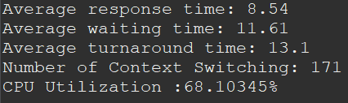

The simulation result of 100 processes with a quantum of 13 for the first round-robin (RR) queue and 3 for the second queue On Same DATA SET.

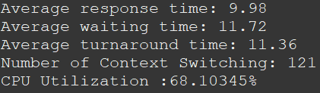

The simulation result of 1000 processes with a quantum of 3 for the first round-robin (RR) queue and 6 for the second queue.

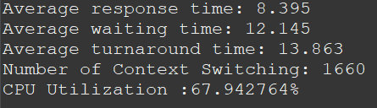

The simulation result of 1000 processes with a quantum of 13 for the first round-robin (RR) queue and 3 for the second queue On Same DATA SET.

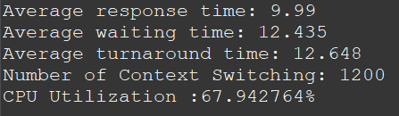

The simulation result of 10000 processes with a quantum of 3 for the first round-robin (RR) queue and 6 for the second queue.

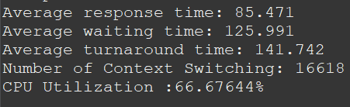

The simulation result of 10000 processes with a quantum of 13 for the first round-robin (RR) queue and 3 for the second queue On Same DATA SET.

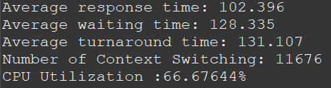

1. **RESULT ANALYZE**

The analysis of the simulation results reveals that increasing the quantum value in the Multilevel Feedback Queue (MLFQ) algorithm leads to a decrease in the number of context switches and turnaround time. However, this reduction comes at the expense of increased response time and waiting time (11). The trends observed in Figure 1, Figure 2, and Figure 3 visually support these findings.

By increasing the quantum value, processes are allowed to run for longer durations before being preempted, resulting in a decrease in the number of context switches and improved turnaround time (11). However, this can lead to increased response time and waiting time as processes wait longer for CPU allocation (12).

To achieve a balance between reducing context switches and optimizing response time and waiting time, adjustments to the quantum value and other scheduling parameters are necessary (13). Careful fine-tuning of these matrices based on specific system requirements and workload characteristics is crucial.

The graphical representations in Figure 1, Figure 2, and Figure 3 provide a clear visualization of the observed changes in context switches, turnaround time, response time, and waiting time, reinforcing the need for matrix adjustments to optimize system performance.

Further research and analysis are warranted to explore the relationships between the quantum value, context switching, turnaround time, response time, and waiting time in order to develop more effective scheduling strategies within the MLFQ algorithm. 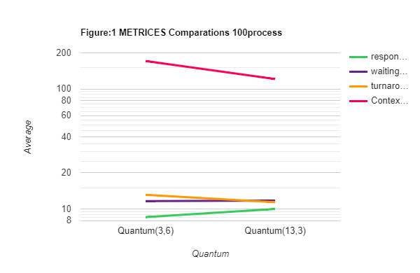

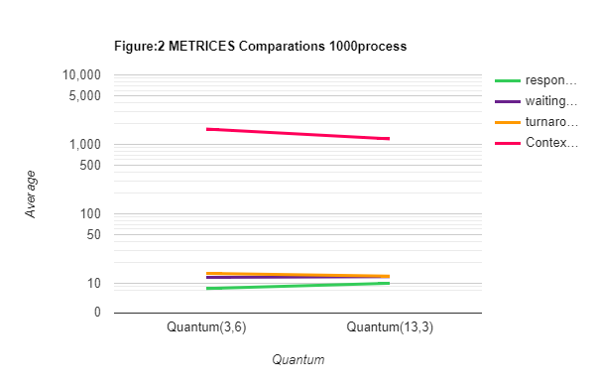

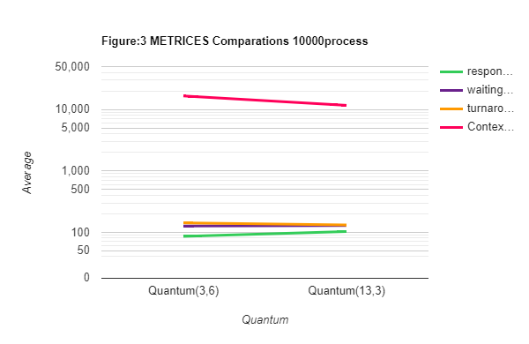

1. DISCUSSIONS

The discussion revolves around the impact of changing the quantum value in the MLFQ algorithm on context switching and the significance of such changes.

The quantum value determines the amount of time allocated to each process in a given queue before a context switch occurs (14). By increasing the quantum value, the scheduler allows each process to execute for a longer duration before preempting it and switching to another process. This leads to a decrease in the frequency of context switching.

Reducing the number of context switches can have several advantages. Firstly, context switching is a time-consuming operation that introduces overhead and can impact overall system performance (15). By minimizing context switches, the system can devote more time to actual process execution, resulting in improved efficiency.

Additionally, frequent context switches may disrupt the execution flow of processes, leading to increased response time and waiting time (16). When the quantum value is increased, processes have a longer uninterrupted execution time, reducing the need for frequent context switches and improving response time.

However, it is important to consider the trade-offs. Increasing the quantum value may reduce context switches, but it can also lead to longer turnaround times for certain processes. Processes with shorter burst times may have to wait longer to regain CPU execution, causing potential delays and increased waiting time.

The importance of changing context switching lies in finding the right balance between reducing context switches and optimizing other performance metrics. Fine-tuning the quantum value allows system designers to adjust the scheduling algorithm to meet specific requirements (17). For example, in time-sensitive systems where minimizing response time is critical, a smaller quantum value might be preferred to ensure more frequent context switches and quicker process execution.

In contrast, for CPU-bound applications where reducing overhead is essential, a larger quantum value can be selected to minimize context switches and improve overall efficiency.

Overall, the impact of changing the quantum value on context switching underscores the need for careful consideration of various performance metrics and system requirements. Finding the optimal balance between context switching and other performance factors is crucial in achieving an efficient and responsive scheduling algorithm.

1. CONCLUSION

The quantum value is a key parameter in the Multilevel Feedback Queue (MLFQ) algorithm that affects various performance metrics, such as context switching, system throughput, and response time (1). Context switching is especially important for system performance, as it involves saving and restoring the state of a process and switching the CPU from one process to another (18). The findings of this study show that by manipulating the quantum value, we can fine-tune these metrics according to our specific needs. For example, by choosing a smaller quantum value, we can reduce the average waiting time and increase the system fairness, but at the cost of increasing the context switching overhead (19). Conversely, by choosing a larger quantum value, we can reduce the context switching overhead, but at the cost of increasing the average waiting time and decreasing the system fairness [. Therefore, it is essential to find a balance between minimizing context switching and achieving our performance objectives. Hence, adjusting the quantum value is a vital step in customizing the MLFQ algorithm to suit our particular requirements and enhance the overall system efficiency.

Authors

**First Author** and the other authors may include biographies at the end of regular papers. In this section authors can included their studies number of publications they have and any achievements the authors have obtained. All the authors can included their photos as well as biographies, if they wish.